Section 1: Carousel Page

- Digital Lock
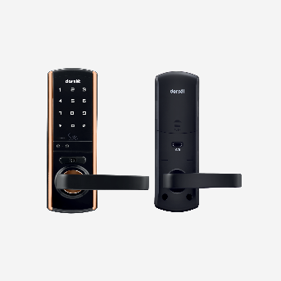
Sub Category:
- Luna Pro+ Facial
- YMI70A-YH
- YDM7116A-YH
- By You V Pro
- Finger prints locks
- Face id locks

- Safe Lock
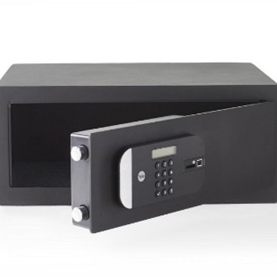
Sub Category:
- NX ADVANCED 560L (Digi+Bio+KL)
- NXADVANCED 370L (Digi+Bio+KL)
- NX ADVANCED 210L (Digi+Bio+KL)

- Mortice Handle
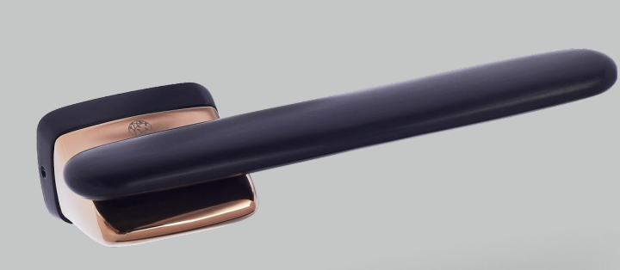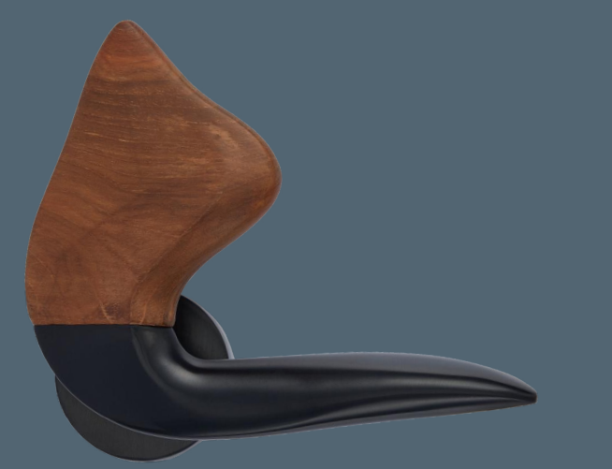

- Knobs

Sub category:
Sizes : 30mm , 50mm, 40mm

- Pull Handle

